CASA SENIOR NETBALL YR 7 GALA DAY – 2026
Thursday 17th September

Host School: Thomas Hassall Anglican College

Location: Thomas Hassall Anglican College
125 Kingsford Smith Avenue, Middleton Grange, NSW 2171 - Gate 1

Warm Up: 8.30am
Start: 9.00am

Finish: 1.30pm

Umpires: Each School provides one umpire for each of their games. These can be capable students.

Canteen: The college canteen will be open and accessible for CASA students

Post Pads: THAC to provide

First Aid: A first aid officer will be present on the day to look after injuries. Please make sure that your players bring their own strapping.

Extras: The draw and rules are on the following pages.

If there are any problems or questions, please feel free to contact THAC mobile 0429 109 769

Parking: There is limited space to park at or near the College. If you have a school minibus (12-seater) there will be space available through Gate 1 (see below)

Please drive up Flynn Avenue and enter Gate 1A/B. Park buses on the gravel area. There is room for 8 mini buses in this area. If you are bringing a larger bus, please park on the street (Flynn Av) between Gate 1 and 2.

RULES

The CASA Gala Day will be governed by the rules according to the All Australian Netball Association. The following rules will also apply.

- Playing time will be 12 minutes per half with a 2-minute half time and 3 minutes change between games for year 7 teams
- All matches to be played as per the Australian Netball Federation rules.

- Playing time will commence at the start of the hooter and stop with the hooter.

- Immediately after the match a representative from the winning team should bring the score sheet to the recording desk.

- The umpires will be checking nails, jewelry, sunglasses and hard rimed caps. Players will not be able to take the court with fake or long nails, jewelry (This includes taped earrings and nails), sunglasses (unless prescription)

- There is no injury time or time stopped for any reason except blood where there is a period of 30 seconds allowed. If there is an emergency the game will be moved over to the nearest court.

- Each division will be allocated courts where the round robin games will be played. (See Draw) If there are any disputes, a teacher from the school ONLY should contact THAC Convenour if there are any disputes that need to be dealt with.

- Year 7 teams will be playing each other in a round robin format.

- Calculating points: 3 for a win, 2 for a draw and 1 for a loss will decide the winner of each division.

- In the event of a drawn result with deciding the overall winner a count back will take place.

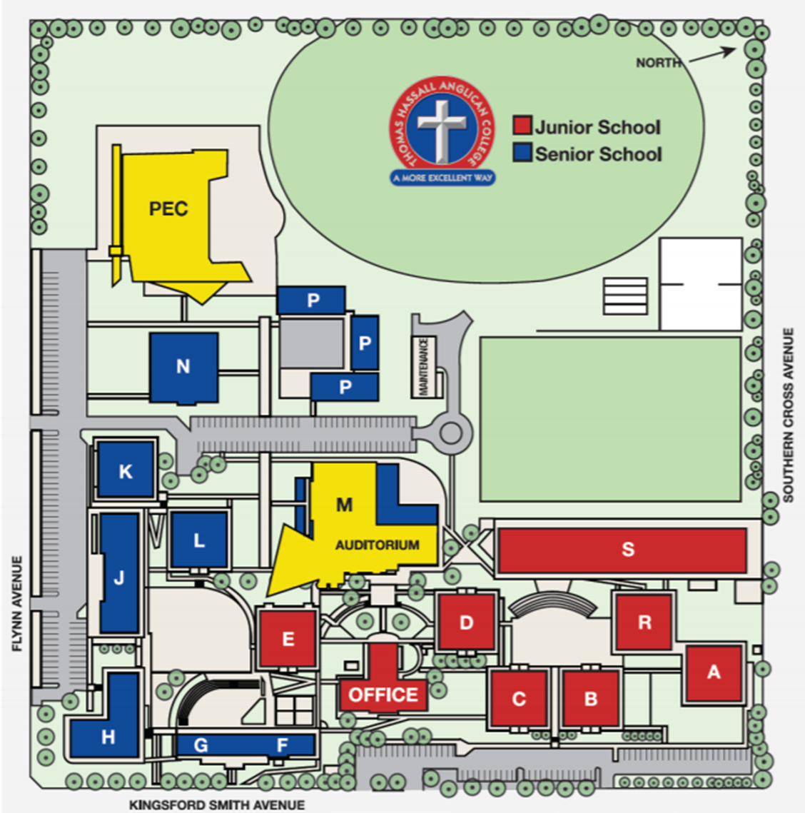
- In the event of a team running late for a game, a point will be awarded for each minute they are late. This will be left to the discretion of the umpire who will then bring the results to the recording desk.

Year 7 DRAW- 2026

POOL A | POOL B
GRG | TIGS
THAC | WAC
SLGS | PAC
BAC | MAS

COURT  TIME / ROUND | PEC Court 1 | PEC Court 2
1  9.00 – 9.30 | POOL B  PAC vs MAS | POOL B  TIGS vs WAC
2  9.30 – 10.00 | POOL A  SLGS vs BAC | POOL A  GRG vs THAC
3  10.00-10:30 | POOL B  PAC vs TIGS | POOL B  MAS vs WAC
4  10.30 – 11.00 | POOL A  SLGS vs GRG | POOL A  THAC vs BAC
5  11.00 – 11.30 | POOL B  PAC vs WAC | POOL B  TIGS vs MAS
6  11.30 - 12.00 | POOL A  SLGS vs THAC | POOL A  GRG vs BAC
Final  12.00 - 12.30 | 1st POOL A vs 2nd POOL B  (Game 1) | 1st POOL B vs 2nd POOL A  (Game 2)
Final  12.30 - 1.00 | 3rd POOL A vs 4th POOL B | 3rd POOL B vs 4th POOL A
Grand Final  1.00 - 1.30 | Winner from GAME 1 vs  Winner from GAME 2
1.30 | Games Finished

